cmd

------

1. psql -U postgres -p 5434

2. postgres=# create user odoo with password 'odoo' createdb createrole login;

3. postgres=# \du

vscode

-------

4. buka vscode, open folder "TrainingOdoo"

5. Install Ext Odoo Extension Pack

6. Install Ext Arkdemy Odoo Training

7. buka new terminal

8. cek versi python :

python --version

9. python -m pip install virtualenv

10. buatkan virtual env :

python -m virtualenv training

11. kalau ada error virtualenv, jalankan :

SET ExecutionPolicy Unrestricted

pilih [A] Yes To All

12. .\training\Scripts\activate

13. libsass di file requirements dicomment dulu

14. python -m pip install setuptools libsass

15. python -m pip install -r ..\odoo-17.0\server\requirements.txt

16. buatkan file configuration

Simpan di : D:\ODOO\TrainingOdoo\training.conf

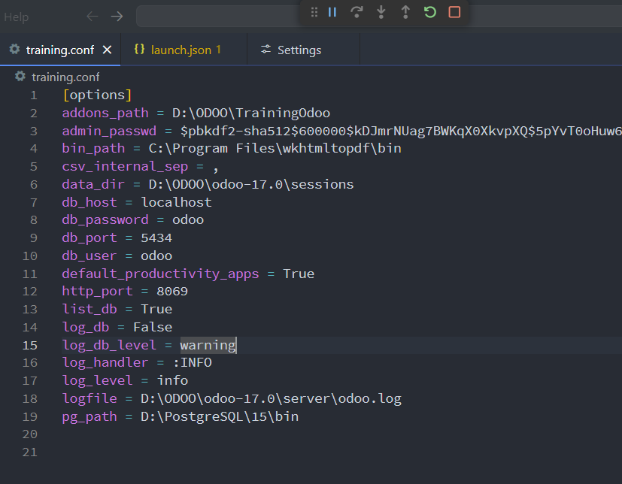

17. buatkan exec vscode :

klik Run and Debug

create python debugger > json > file python

akan terbentuk file launch.json di folder .vscode

setting di file tsb sbb:

{

// Use IntelliSense to learn about possible attributes.

// Hover to view descriptions of existing attributes.

// For more information, visit: https://go.microsoft.com/fwlink/?linkid=830387

"version": "0.2.0",

"configurations": [

{

"name": "Training Odoo",

"type": "python",

"request": "launch",

"stopOnEntry": false,

// "program": "${file}",

"console": "integratedTerminal",

// "python": "${command:python.interpreterPath}"

"python": "D:\\ODOO\\TrainingOdoo\\training\\Scripts\\python",

"program": "D:\\ODOO\\odoo-17.0\\server\\odoo-bin",

"args": [

"--config=D:\\ODOO\\TrainingOdoo\\training.conf",

"--dev=xml",

]

}

]

}

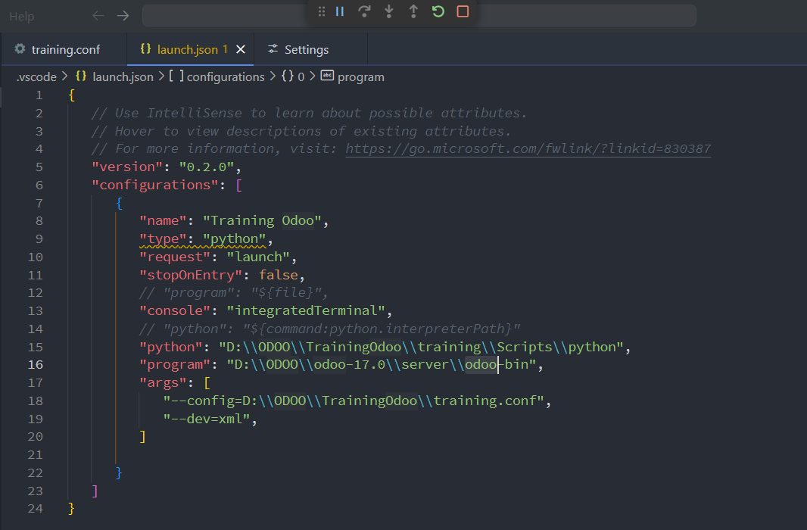

18. Run

19. install Ext Odoo Scaffold (untuk membuat Template odoo)

klik tombol gear setting

pilih odoo extension setting

isi odoo bin path : D:\\ODOO\\odoo-17.0\\server\\odoo-bin

isi python virtual env : D:\\ODOO\\TrainingOdoo\\training\\Scripts\\python

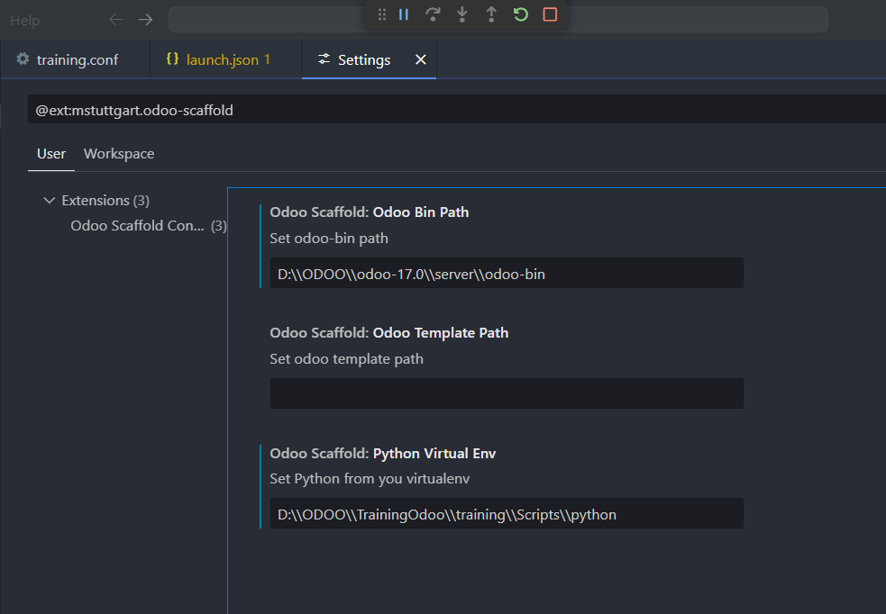

Github

-------

20. instalasi Git, tambahkan folder bin ke dlm env

21. git --version

22. git config --global user.email [endie.liu@gmail.com](mailto:endie.liu@gmail.com)

git config --global user.name "endie.liu"

23. buka terminal baru :

git init

git add .

git commit -m "Training-Technical"

git branch -M main

git remote add origin <https://github.com/endieliu/Training-Technical.git>

git push -u origin main

24. cek repo github